CalQRP Analog Power Meter

Assembly Guide

John Sutter

W1JDS

[jds@sutters.com](mailto:jds@sutters.com)

Rev 1.1

August 7, 2018

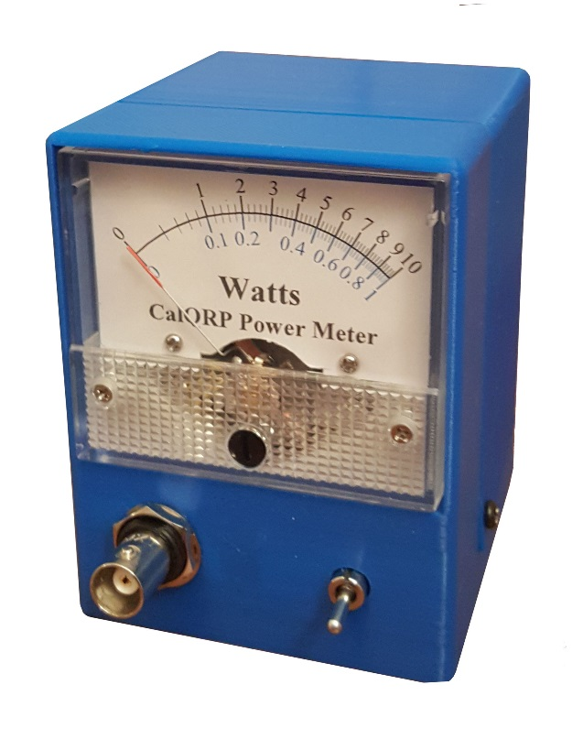

About 3 weeks ago Doug Hendricks, KI6DS, mentioned he had a club project idea. I think he said he had some low cost meters and thought it would be good to spin an old project, the [Christmas Power Meter](http://www.norcalqrp.org/norcalchristmaspowermeter.htm), using the latest/greatest tools of the day which I’m sure will be laughable in another decade. That earlier project by apparently had the same instigator.

Like the original by Song Kang, WA3AYQ and Bob Okas, W3CD, this version of the meter has two ranges, 1W and 10W using a SPDT switch to select between them instead of 2 BNC connectors. Beyond that, the schematic is pretty much the same.

The tools I used:

|  |  |
| --- | --- |
| **Schematic Capture** | [KiCAD](http://kicad-pcb.org/) |
| **PCB Layout** | [KiCAD](http://kicad-pcb.org/) |
| **PCB Fabrication** | [AllPCB](https://www.allpcb.com/) |
| **Enclosure Design** | [OpenSCAD](http://www.openscad.org/) |
| **3D Printer** | [Creality CR-10](https://www.creality3d.cn/creality-cr-10-3d-printer-p00096p1.html) |

# The Circuit

As mentioned earlier the schematic matches the Christmas Power Meter pretty closely. SW1 is used to switch the power from the BNC connector into either the 10W load consisting of four 200 Ω 3 Watt carbon film resistors or the 1W load consisting of two 100 Ω ½ Watt carbon film resistors. The diodes are used as detectors with the resulting voltage filtered by the capacitors. The resistors are used to adjust the full-scale current to 200 μA. More on that later.

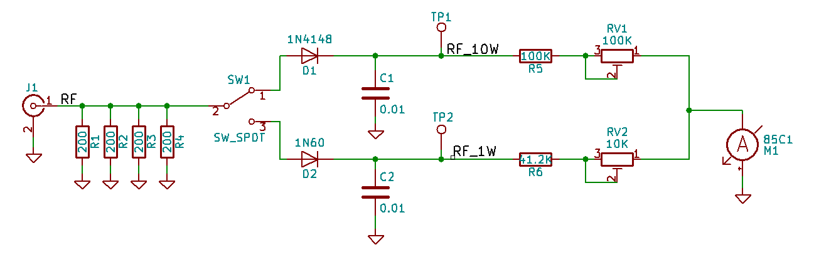

Figure 1 Schematic

A germanium diode was used on the 1 W range due to its lower voltage drop. More on that later. If you decide to use a through hole switch, the maximum shaft diameter is 6.3 mm. The BNC connector hole diameter is 9.3 mm with a flat edge.

Table 1 Parts List

|  |  |  |  |
| --- | --- | --- | --- |
| **Reference** | **Component** | **Value/PN** | **Rating** |
| C1, C2 | Ceramic Capacitor | 0.01 | 50 V |
| D1 | Diode, Silicon | 1N4148 |  |
| D2 | Diode, Germanium | 1N60 |  |
| J1 | BNC Connector | Through-hole or panel mount | |
| M1 | [Meter](https://www.amazon.com/uxcell-Current-Ammeter-Circuit-Testing/dp/B07CN1115K/ref=sr_1_2?ie=UTF8&qid=1533492453&sr=8-2&keywords=uxcell+200ua+meter) | 85C1 | 200 uA |
| RV1 | Trim pot | 100 K |  |
| RV2 | Trim pot | 10 K |  |
| R1-R4 | Metal film Resistor | 200 | 3 W |
| R5 | Metal film Resistor | 100 K | 1/4 W |
| R6 | Metal film Resistor | 41.2 K | 1/4 W |
| SW1 | SPDT Switch | C&K 7101MD9AV2BE or panel mount | |

The link for the meter is to one available on Amazon. They are available at much lower cost on eBay and other sites. It is important that it is an 85C1 200 uA meter.

When choosing resistors for the dummy load, R1-R4, try to get the parallel resistance as close to 50 Ω as possible. Mine came out to 50.7 Ω. I could have done better, but that is close enough.

# The Tools

No fancy tools are required to clean up or assemble the power meter. As you clean up 3D printed parts you will develop a repertoire of techniques that work for you.

Table 2 Cleanup Tools

|  |
| --- |
| Cleanup Tools |
| Pocketknife |
| Craft knife such as X-acto |
| Needle nose or flat pliers |
| Sandpaper |
| File |

Table 3 Assembly Tools

|  |
| --- |
| Assembly Tools |
| 1/8" Drill bit |
| Drill |
| #1/small Phillips screw driver |
| Pliers or adjustable wrench |

# The PCB

Although a PCB is not required for this project, it gives better results than breadboarding on perf board. There’s more info on this later. Manhattan style might give similar results to PCB. The size of 50x50 mm was chosen because it was big enough and a relatively cheap size to get made

This was my 5th design using KiCAD so I’m getting pretty comfortable with it. I used a lot of grounding and vias on this design, used wider traces for RF and ground signals, and tried to keep everything tidy.

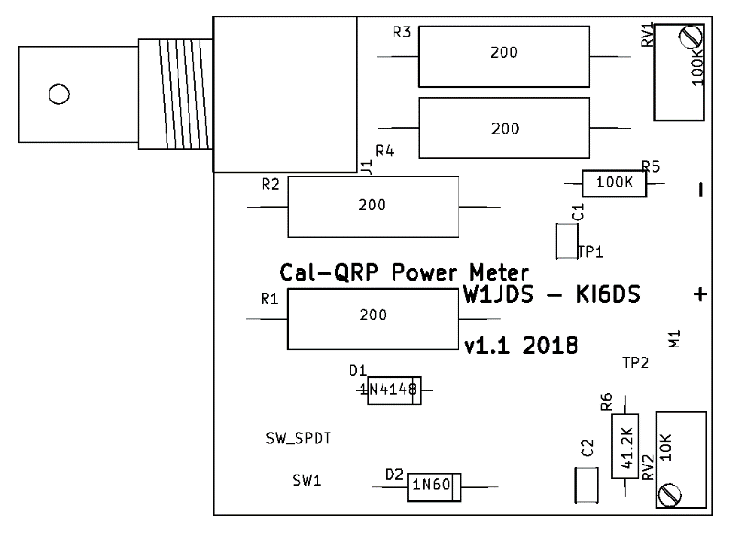

Figure 2 PCB Floorplan

The PCB size allowed a lot of space for components. The PCB is laid out to accommodate a pretty common through hole BNC connector and a C&K through hole switch I have a small number of from old test fixtures. Panel mount parts can also be used as long as wires are put in the right holes. The figure below shows the layout and wiring connections. Note that the top and bottom are flooded with ground so the ground traces are not shown.

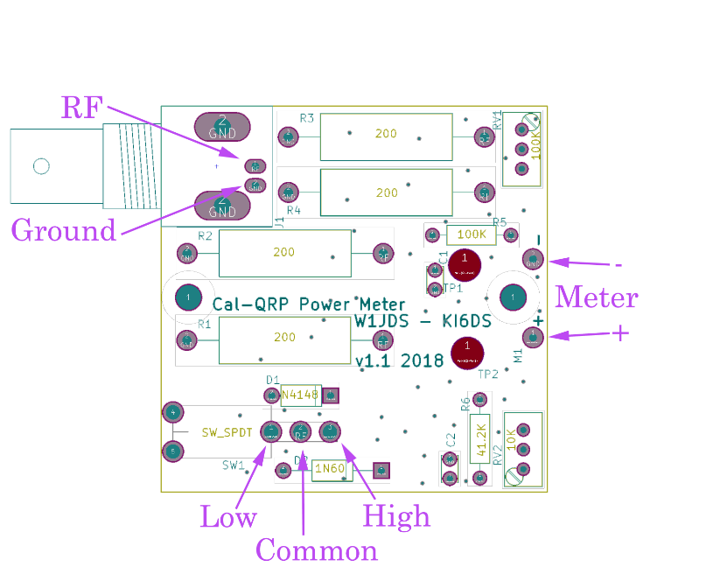

Figure 3 PCB Layout and Wiring

One of the cool features of KiCAD is the 3D viewer. Models for many components come with the package. If you make your own components, you’ll need to make 3D models too if you want them to show up. I was hoping to use the model in my 3D modelling tool to check for sizing and clearance. I did it, but it was not easy and didn’t really work so great. Hopefully things are better in the new release.

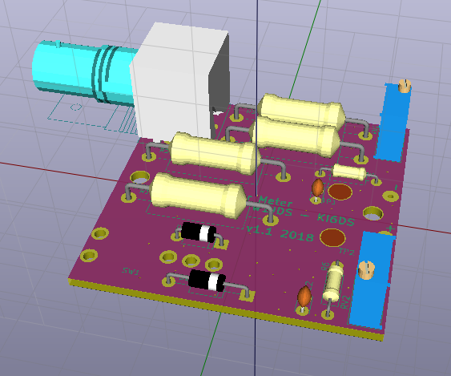

Figure 4 PCB 3D-View

I used ALLPCB to fabricate the PCB mostly out of inertia. I’ve done several designs through them and am familiar with the processes and requirements. This time I noticed that I could get black on white silkscreen/soldermask for the same price as the usual white on green. In hindsight, I’ll stick with white on green because it is easier to follow traces.

I submitted my design on a Tuesday evening, late. I got feedback in the morning asking if maybe I forgot to send a drill file. Sure enough, KiCAD made two different drill files, one for plated holes and one not plated. The one I send did not include the mounting holes. I submitted a drill file containing both (that’s an option when plotting to Gerber files) and my fabrication started Wednesday. Monday afternoon I had 10 PCBs in my hands.

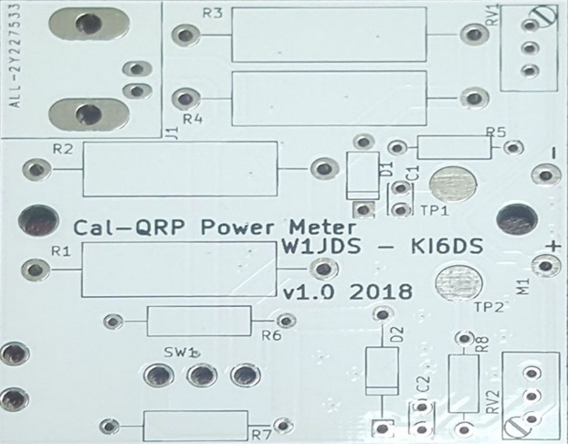

Figure 5 Fabricated PCB (PCB v1.0 shown)

While the PCB was being fabricated, I breadboarded the circuit so I could get going on the enclosure. More on that later.

# PCB Assembly

Just put the right parts in the right holes, OK? Check the smaller resistors with a DMM if you don’t know the color chart. Check them anyway because you stayed up too late again and can’t see too clearly. The only tricky part might be the diodes. Make sure the stripe on the part matches the same end as the PCB. The germanium diode is almost always going to be the larger of the two if you get confused. It wouldn’t be a bad idea to center the trim pots before you solder them in, but it’s not critical.

If you are using panel mount parts, solder your connecting wires to the PCB and strip & tin the component ends to make it easier to solder when putting the PCB in the case.

I personally like to use a dab of hot glue on all my wires leaving a PCB as strain relief.

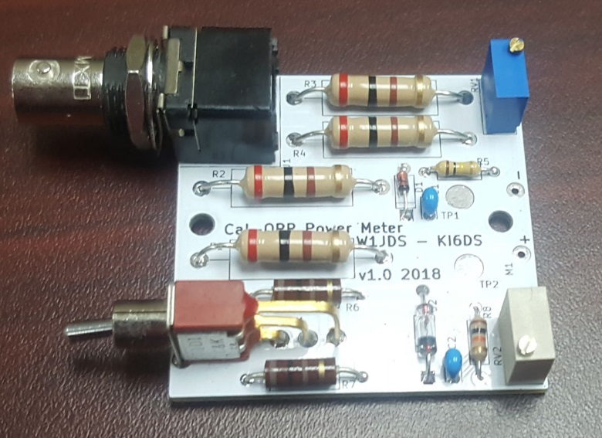

Figure 6 Assembled PCB (PCB v1.0 shown)

Clean up any flux on the bottom of the board and make sure the joints are good. I had some odd behavior when checking the PCB out on a vector analyzer that cleaned up with the switch was resoldered. BTW, if you use cheap switches be prepared to replace them if the contacts are bad. Note that R8 shown in the assembled PCB image is not the current value.

**It wouldn’t be a bad idea at this point to do connect the switch and BNC connector if you’re using panel mount parts and run through calibration just to make sure all is well.**

# The Enclosure

I used OpenSCAD to design the enclosure. Typically when I start a design I spend a lot of time measuring components and making models of them. This time I tried to export the 3D model of the assembled PCB from KiCAD. It took quite a bit of massaging before I got something usable that way. I would have been better off modeling it myself. I’ll try the new version of KiCAD later to see if things have improved.

OpenSCAD is a text-based tool. Using this tool mostly consists of adding and subtracting geometry that is translated, rotated, scaled, etc… It can get tedious and repetitive but if one is careful the design can be made parametric. That is, making a change to the size of a component in one location can propagate through the design making it easy to tweak a design. It’s a good idea to make slight changes anyways to make sure your model behaves properly.

I split the enclosure into two parts: a base and a top. There are two versions of the base to accommodate through hole parts and panel mount parts. The difference being hole sizes and vertical offsets. Below is an image of an early model showing the base with the exported PCB and a meter model. This version was rejected due to it being front-heavy, prone to falling forward. The solution was to press the meter into the housing and making the base deeper.

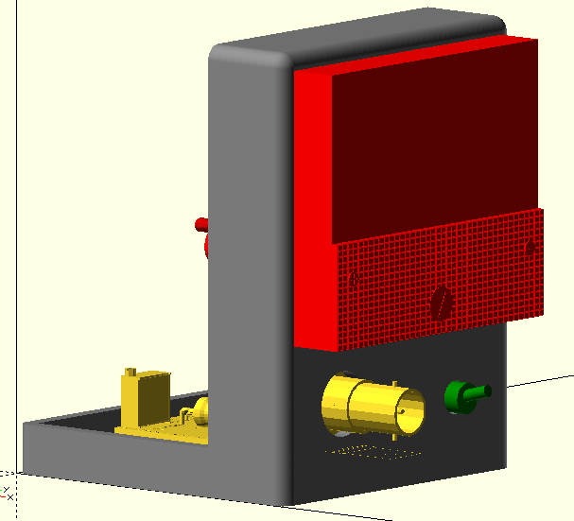 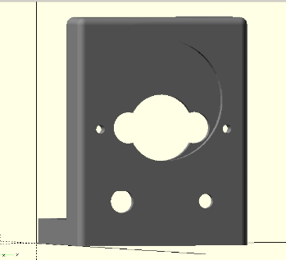

Figure 7 Early Enclosure Design

Another challenge was that an accurate model for the meter was not available. I found one by [Mark BuBi](https://grabcad.com/library/analog-current-meter-30ma-1) that was pretty close, so I used it. I tried to get fancy fitting all the shapes of the back of the meter. Several test prints later, I ended up just making a single big hole to fit the body of the mater and two holes for the mounting screws.

The top is just the rest of the box form used for the base with screw holes. Supports were added to the base to make the top fit snugly.

Often when designing something, measurements need to be taken to ensure the design is correct. OpenSCAD does not have tools for this, but there are tools that can work with STL files exported by OpenSCAD and other tools. A tool I used quite a bit to verify dimensions and clearance is the free 3D-Tool STL viewer from [3D-Tools.com](https://www.3d-tool.com/). STL files are also used for 3D printing. The snapshot below shows measurements of meter features.

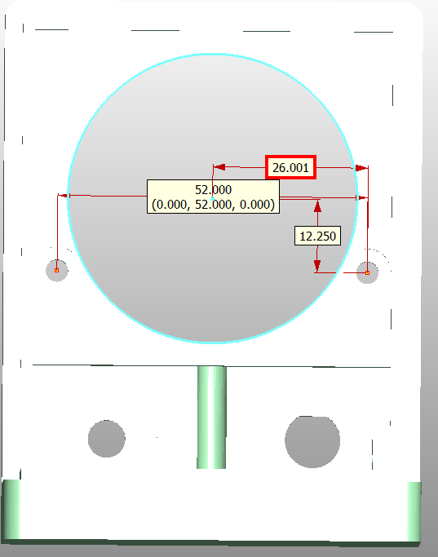

Figure 8 Measurements from 3D-Tool

# Printing

I did many test prints trying different designs, features, dimensions. I also had quite a few printer failures while trying to get this design finished. The last was a bad clog of the hot end that required complete disassembly and cleaning. That was about 3 hours of work.

There are 3 STL files:

* base_panel_mount.stl
* base_through_hole.stl
* top.stl

Print whichever base is right for you. I use Cura to slice my STL files to product the GCODE files. I tend to print in PLA at a layer height of 0.12 mm. On my Creality CR-10 printer it takes about 14 hours to print a base and 12 hours for a top. You’ll want to print with supports and about 20% infill. I also tend to print with a skirt to help keep the parts attached to the bed while printing. Be sure to level your bed often or suffer the consequences…

Here are a few shots right off the printer (one still on the printer bed).

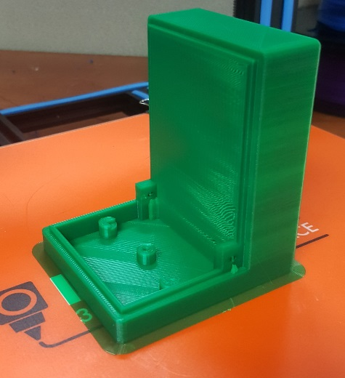

Figure 9 Base on the Printer with Support Material

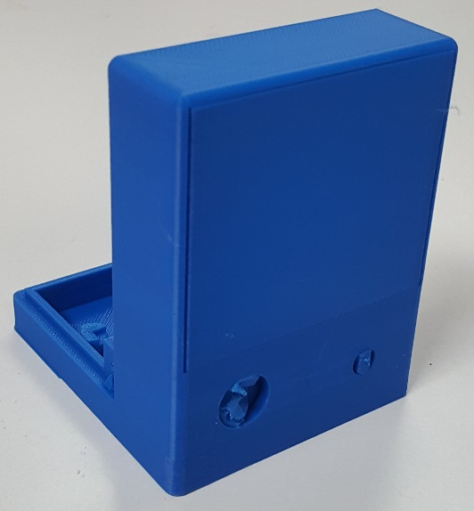

Figure 10 Base with Support Material

# Cleanup

The next step is to remove all the support material and trim edges. I tend to use needle nose pliers to rip most of the support material out and a pocket knife to trim edges that have excess material. Sometimes a drill bit or pick is needed to clean up a hole. One hole that might be tricking to clean is the front PCB mount. There is an access hole in the meter housing area that can be used to access the front PCB mount. I usually use a long, skinny Philips screw driver to open that hole up enough as well as driving the screw during assembly

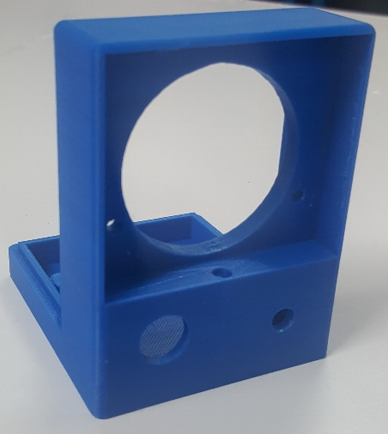 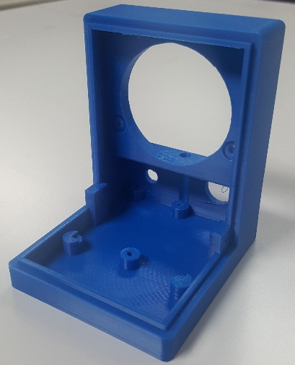

Figure 11 Cleaned up Model

# Meter Face

I used a graphical layout tool called [Galva](http://www.f5bu.fr/galva-about/) to lay out the new meter face. It’s a little challenging, but I got a nice face out of it. You’ll need WinXP or so to run it, or at least I did. Fortunately, we still have a few of those running around the labs at work.

Remove the two cover screws to open the front of the meter. There are two more screws to remove to get at the existing face. Cut the printed label along the blue outline and the gray areas. You can just poke out the holes with a pencil if you overlay the face on the metal face. Now is a good time to trim any extra paper near the meter movement. My needle was hung up on the face as it is. I might fix the face someday, but probably not. Attach the scale using thin double-sided sticky tape, glue, whatever you have. The 2” and 50 mm lines are there for reference if you happen to use this document instead of the supplied PDF for the face.

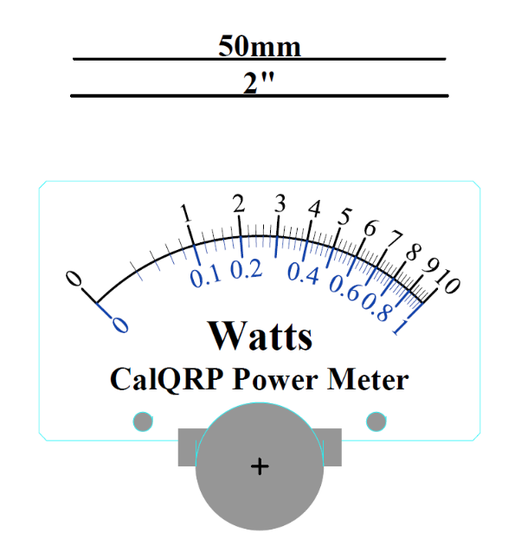

Figure Meter Face

Put the face back together double checking that the meter movement is clear of the new face.

# Assembly

Assembly is straightforward. If you are using a panel mount switch and BNC connector, solder the BNC ground lug to the ground wire and install them now. Next slide in the PCB. I found my fit was snug and the PCB snapped into place. Push on the edge of the PCB, not the trim pots. Solder the wires for the BNC connector and switch. Place a label on the front panel for the correct high/low setting of the switch. If you managed to find one of those C&K switches, note that the 10W range is selected with the switch down. If I spin the PCB I’ll fix that.

If the meter face is available print one out and trim it to size using the existing face as a template if needed. If you printed on very heavy paper or cardstock, you might be able to use it by itself, otherwise, attach the new face to the existing metal face.

Next, screw the PCB down with two ¼” #4-40 screws. The back screw is easy. Use the access hole for the front screw. Insert the meter from the front. Be sure to remove the mounting nuts and washers from the meter body before doing this and to put them back on afterwards.

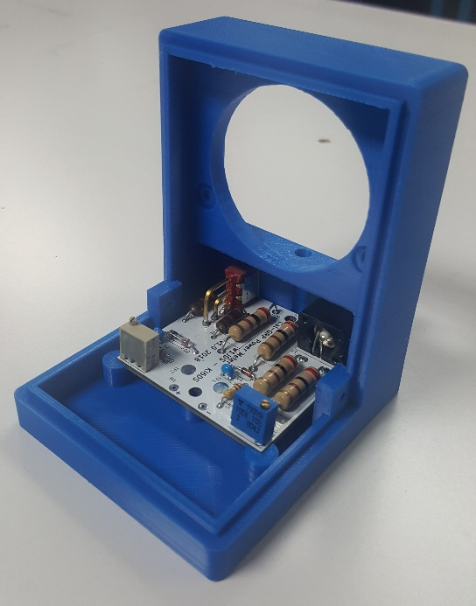

Figure 13 PCB Installed (PCB v1.0 shown)

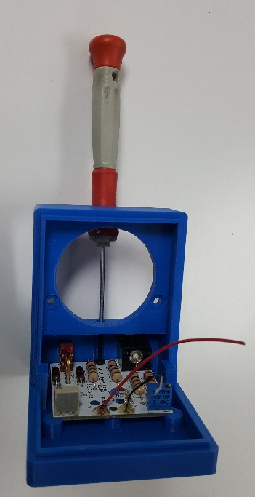

Figure 14 The Access Hole (PCB v1.0 shown)

Strip the wires from the PCB to the meter and attach them to the meter. Tighten the nuts.

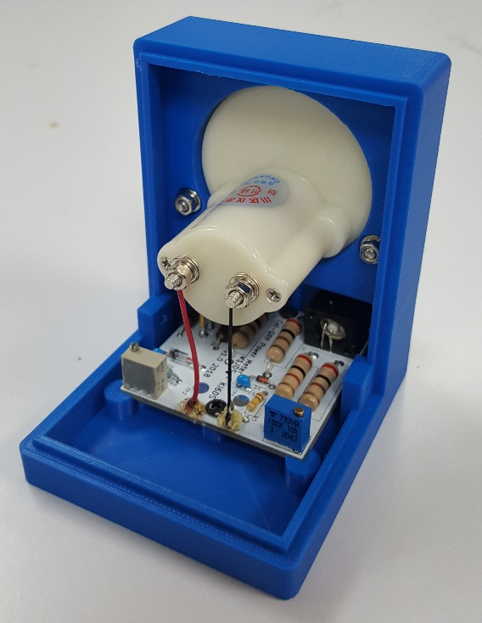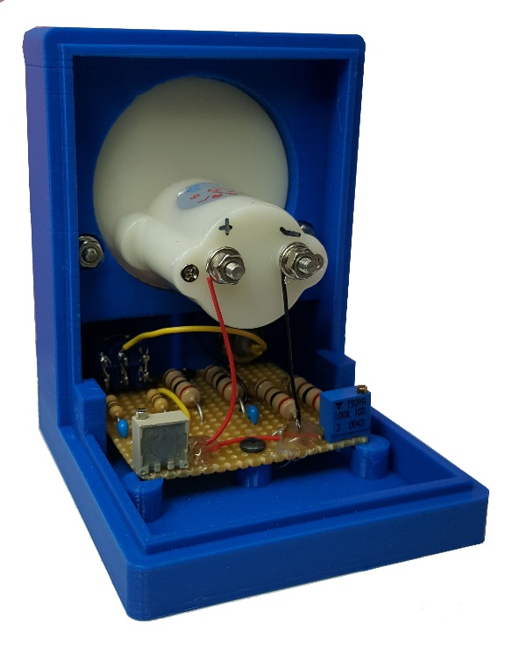

Figure 15 Meter Wired Up (PCB v1.0 shown)

Slip the top on to the base and check the screw holes to make sure they line up. Clean up the edges and holes as necessary. Use two more ¼” #4-40 screws to attach the top.

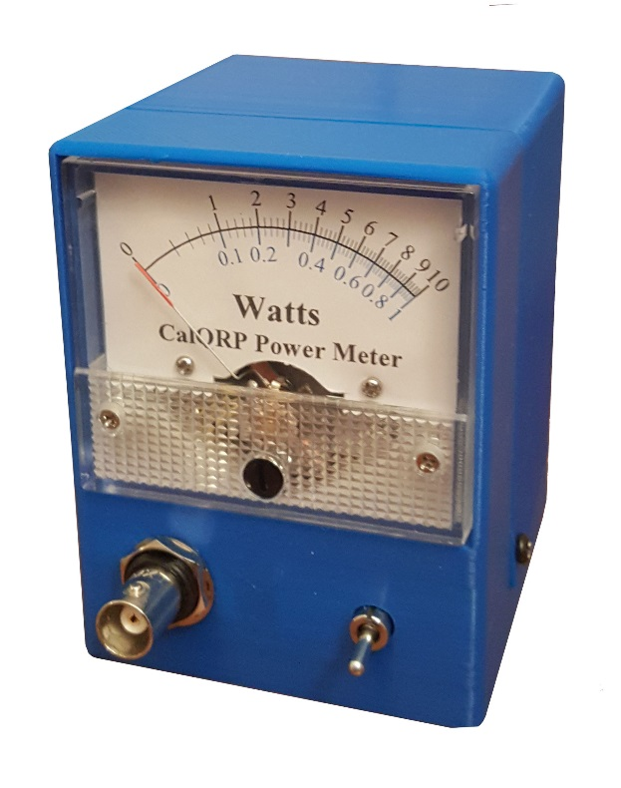

Figure 16 One power meter screwed up and ready to go

# Calibration

Calibration is straight forward. Simply connect your calibrated 10W source, adjust RV1 for the full-scale reading, connect your calibrated 1W source, and finally adjust RV2 for the full-scale reading. What could be simpler?

What? You don’t have calibrated sources? I was hoping you would, because I don’t. I don’t even have a radio that puts out 5 W yet.

What we can do for now is to calculate the voltage we should see at the capacitors:

V2 =P2 x 2 * Rload

For the ideal case with Rload = 50 Ω, 1 W gives 10 V and 10 W gives about 31.6 V. This is not an ideal life, so plug in the value measured earlier. You did measure it, right? If not, just measure it at the BNC now.

For my meter with Rload of 50.7 that comes out to 10.07 and 31.43 V. Just connect a variable power supply to the BNC connector at the calculated low and high power values and adjust the RV2 or RV1 to show full scale. Be sure to have the switch set to the right range. You will smoke the low range resistors if you hit them with 10W, well V1.0 would have, but V1.1 uses the same dummy load for both ranges. For this to work, your power supply will need to be able put out 31+ V at a little over 0.6 A.

An alternative is to apply a voltage on the other side of the diode. To do this, you need to measure the voltage drop. Put 10V into the BNC connector and measure the voltage across each diode with the range switch set appropriately. In my case I got 0.196 V for D2 and 0.459 for D1. Subtract the drop voltages from the calculated values. Apply the voltages to TP2 and TP1 respectively and just RV2 and RV1 for full scale readings.

In my case the voltages would be:

Vlow = 10.07 – 0.196 = 9.874 V

Vhigh = 31.432 – 0.459 = 30.973 V

That should be a good enough calibration. Even better would be to use a strong enough RF source and attenuation to get a 1 W and 10 W source confirmed with a spectrum analyzer and calibrate against that.

I checked the SWR of the meter (v1.0) on a network analyzer from 3 to 20 MHz at work and got pretty decent results. The perf board prototype was the worst performer. The worst SWR measured was about 1.03 at 3 MHz. Also shown below are values for a digital power meter I did earlier in the year, both a perf board build and a PCB version.

Figure SWR